Task 5.1p: Making a GUI
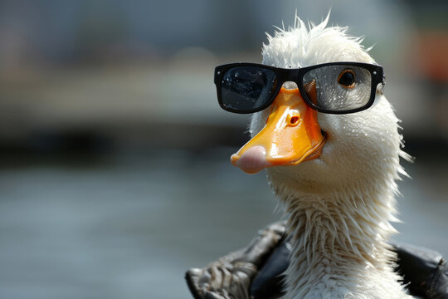

It was looking a little empty so here’s a cool duck

GitHub link: https://github.com/charlieM044/SIT210/tree/41e556f2402243a88c50e429728561ee92f130f2/task%205.1
Video link: https://youtube.com/shorts/eSlYbkFKKLM?feature=share

